CS249 Data Mining Project

Analysis and Prediction of Information Spreading in Weblog Space

Mojdeh Makabi, Richard Sia, Tree Li
{mojdeh,kcsia,treetree}@cs.ucla.edu

Abstract

World Wide Web is being transformed as new tools such as Weblogs have taken hold. Weblogs (Blogs) is a structure through which new ideas and discourses flow easily. A significant use of Weblogs is a as publicly exposed, online diary describing both real-world and web-based experiences. Bloggers frequently read each other’s posting. In addition, the phenomenon of listing and commenting on information found through a user’s online exploration is common. In this way, the information propagates rapidly. In this paper, we analyze the pattern of information spreading among Weblogs. In order to study this, we select a collection of Weblog pages, and download them on a regular basis. Then, we analyze them in order to figure out which links are appeared more than a specific number of times, and then we count their frequencies. Afterwards, we study the spreading pattern of the information using some statistic tools. Moreover, we classify the “Hot” Weblogs. Hot Weblogs are Weblogs that often initiate a discussion of hot topic among other Weblog. Since the hot Weblogs have high influence rating, they are considered very effect for marketing and promoting new information. Thus, we figure out some specific traits of hot Weblog. Furthermore, we try to predict the popularity of discussion topics in near future.

1. Introduction

With the increasing use of the Internet, the role of passing around information begins to switch from traditional media (like newspaper, radio, TV, word-of-mouth) to the Internet. One of the phenomenon observed is the Weblogs. Weblogs (or Blogs) are personal web pages created by individuals or small groups of individuals. They are updated frequently (ranges from several times a day to once every week), with the most recent article on the top of a page, an example of this is http://www.lessig.org/blog/ (created by a law school professor in Stanford). The nature of Weblogs span over very diverse topics, they range from personal diaries, collection of photos, to comments on recent issues, etc. It is observed that when a particular Weblog mention about some interesting hot topics, someone read it and find it interesting. They, in return, mention the same topics on their own Weblog and this piece of information keep spreading around until some point that no one is interested any more. For example, on April 27 2004, the Weblog http://slashdot.org mention about the 3rd test release of the Fedora Core, and together with a hyperlink citing the Fedora announcement page (http://www.redhat.com/archives/
fedora-test-list/2004-April/msg02693.html), some people might have read it and if they are fans of Linux, they might also post a comment on this together with the hyperlink on their own Weblog.

In this paper, we present the overview of our project in section 2. In section 3, we explain how we collect the Weblog data and store them in DB2 database for further analysis. In section 4, we describe the three research topics including identify the information spreading pattern, discovering Hot Weblog, and predicating the popularity of discussion topic. Section 5 discusses some of our future interest and conclusion in section 6.

2. Overview

The observation of hyperlink spreading around Weblog shows one form of information flow in a networked world. In this project, we study how a topic of discussion initiates, grows, and dies out. Specifically, we plan to achieve this by tracking the sequence of appearance of these hyperlinks.

Assume we have a collection of 100 Weblog pages downloaded daily. We examine the collection day by day, and figure out which links are mentioned more than a certain number of times. For each link appeared, we count the number of its appearance on the other Weblogs in each day. Referring to the following example, suppose some ground breaking research in Bioinformatics topic is announced by UCLA on Apr 28, one Weblog mention about this and put the link http://www.bioinformatics.ucla.edu/ on it, later, this information spreads around the Weblog community and 2 more Weblog mention UCLA on Apr 29, 8 on Apr 30 and so on. The following table explains the appearance format.

 | Appearance
URL | Apr 28 | Apr 29 | Apr 30 | May 1 | May 2 | May 3 | May 4
http://www.a9.com | 5 | 6 | 2 | 1 | 0 | 0 | 0
http://www.bioinformatics.ucla.edu/ | 1 | 2 | 8 | 3 | 3 | 1 | 0
… | . | . | . | . | . | . | .
…. | . |  | . | . | . | . | .

Based on the time sequence and number of citations, we study how a topic of discussion grows; whether it receives the most number of citations on the first day and dies out quickly; or it grows gradually to reach a maximum point and then dies out gradually, or it grows steadily with 2 or 3 new Weblogs consistently mentioning it daily.

The main purpose of our project is to study and understand the information spreading characteristic in Weblog space. Therefore, we may predict information flow and popularity in Weblog space with given attributes, such as file size, number of image, updating rate, and in/out link.

3. Data collection and preparation

We collected a list of Weblog URL (~40K) from several Weblog hosting website (e.g. http://www.blogger.com, http://www.globeofblogs.com ). We have started crawling the frontpage of these Weblogs since April 12 2004 on an 8 hours basis. The compressed size for each crawl is about 300MB. In our experiment, the set of data being used range from April 12 2004 to May 17 2004, giving us a total of 106 crawls.

We then implemented a parser to scan through these web pages for occurrence of hyperlinks, together with the file size, number of links (both inbound and outbound, which are the links to pages within or out of the same domain of that particular page respectively), number of images, and change frequency of each page. For each hyperlink appeared on a page, we record its first appearance timestamp and associate it with the time when we crawl it. The ER model is used to describe our data is as follows.

page
link
Appearance_time
appearance
pageid
url
linkid
url
Actual time
appear
appear
File Size
# Links
#change
# image
Figure 1. ER diagram used to model Weblog data

4. Research Topics

There is a lot of interesting research topic in Weblog Mining. We decide to focus on the 3 important topics in our project. First, we used k-mean clustering algorithm and Matlab to cluster and visualize pattern of information flow. Then we discussed how we use multiple classifiers to identify the hot information source among Weblog, we called them as “Hot Weblog”. After we discovered the hot Weblog, we use R and Weka to predict the popularity of a topic given some of its attributes.

4.1. Analysis of Information spreading pattern

Motivation

Throughout our experiment, we identify each URL follow some specific pattern that repeatedly cited in different Weblog. This information spreading pattern allows us to gain insight into how information may flow in general throughout the Weblog space. We study the information spreading pattern by mining the appearance time of URL among our data set in a given time period, 15 days, in the web. Therefore, we could study the time at which the citations occurred and the life span of each link. In order to study the information spreading pattern, we apply a clustering method to break down the data set into small set of basic citation patterns in which most URLs follow.

Experiment Setup

In our analysis, we selected a total of 605 potentially interesting URLs which had been cited more than 20 times among the entire Weblogs from April 12, 2004 to May 17, 2004. This threshold value was obtained through some experiments and also suggested by previous web mining research in [1]. Before we performed the clustering analysis, we created a vector for each URL and its dimensions were ordered by day with the first dimension being the count of citation of its first day of appearance. Each vector was normalized with the total number of appearance. Then we applied the “SimpleKMean” clustering algorithm in Weka for this dataset, see Figure 2. The distances between vectors were measured by the Euclidean metric, and cluster centroids were defined as the arithmetic mean of the cluster member vectors.

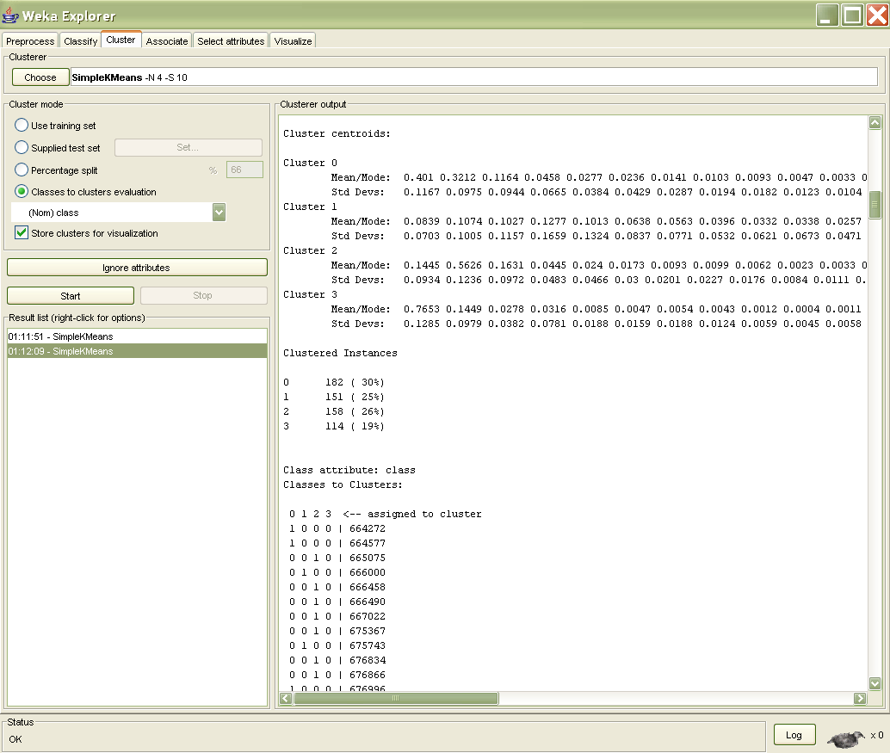
Figure 2. Applied “SimpleKMean” clustering algorithm in Weka for four clusters

Analysis of Result

We tried different number of clusters and found out that the best clustering result could be obtained with four clusters (k=4). Furthermore, increasing k tends to introduce redundant or lower quality clusters. These results were found to be consistent with the experiment in [1]. The following table summarized the number of URLs in each cluster. Figure 3a and 3b show the centroids of the four clusters in k-mean algorithm.

Cluster | Number of URLs | Percentage
1 | 182 | 30%
2 | 151 | 25%
3 | 158 | 26%
4 | 114 | 19%

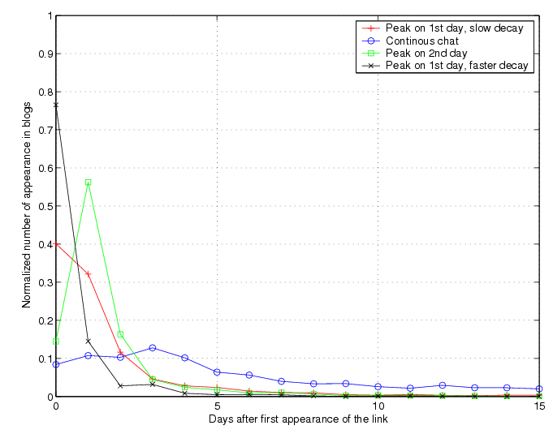
Figure 3a. shows the centroids of the four cluster in k-mean algorithm for 2 weeks period

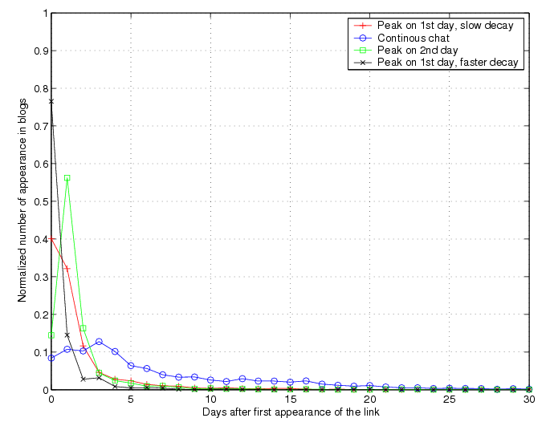
Figure 3b. shows the centroids of the four cluster in k-mean algorithm for about 1 month period

Figure 4 shows four types of information spreading pattern. Cluster (1) contained URLs that have peak on the first day and slower decay, such as President Bush interview on April 13, 2004. The information spreading for important news usually has a slower decay. Cluster (2) represented the sustained interested type of URLs, such as some survey for favorite song in www.youthlink.com/quiz.asp that few people constantly mention about this information for a certain period of time. Cluster (3) contains URLs that had peak on day two followed by a slow decay. Cluster (4) contains URLs that had a peak on day one with faster decay that tends to represent some daily news, such as news in www.cnn.com. We could also see that about 19% of information spreading was in cluster 4 types.

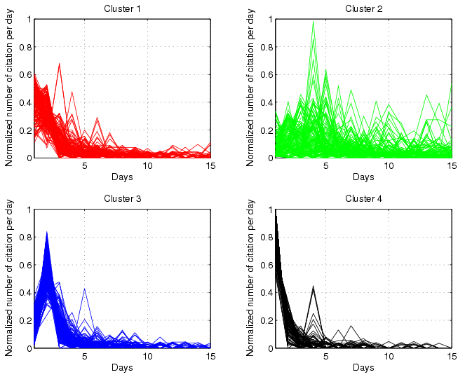
Figure 4. The four information spreading pattern resulting from SimpleKMean clustering algorithm in Weka. Cluster 1 – 182 of 605 URLs have a peak on day one with a slower decay. Cluster 2 – 151 URLs were considered as sustained interested type; Cluster 3 – 158 URLs peak on day two followed by a slow decay; Cluster 4 – 114 URLs have a peak on day one with a faster decay.

4.2 Hot Weblog Discovery

Motivation

Hot Weblog are those Weblogs that manage to be the first or the first group of web pages to mention some particular hyperlinks, which appear abundantly on other Weblogs afterwards. Such Weblogs are considered to have high influence rating and are of central importance from the marketing point of view. So in order to get the set of hot Weblog, the following had to be done:
- Find the Weblogs that mention hot topics on the first day of their appearance
  - Hot topics are the particular hyperlinks that been mentioned on other Weblogs more than some threshold value (in our database, the threshold value for this step is 20)
- From the set of Weblogs obtained in step one, find the subset of Weblogs that are linked by other Weblogs more than a specific threshold value (in our system, the threshold value for this step is 5). This subset contains the set of Hot Webblogs.

Experiment Setup

Threshold values are obtained through experiments. For instance, in one of the cases, the threshold values were too low which resulted in a set of Weblogs that were not in fact very popular Weblog. In another case, we had the threshold value so high, which resulted in a smaller set of hot Weblog. In other words, we were losing some potential hot Weblog. With trial and error, we finally reach these threshold values which we believe gives a set of hot Weblog that are not too general and not too specific.

Here is the SQL Code for obtaining the set of Hot Weblogs:
connect to sample user kdd;

drop table temp;
drop table first_req;
drop table hot_blogs;

create table temp(
url varchar(1024)
);

create table first_req (
linkid integer not null,
url varchar(1024),
primary key (linkid)
);

create table hot_blogs (
pageid integer not null,
url varchar(1024),
primary key (pageid)
);

insert into temp(url)
select distinct(p.url)
from appearance as a, page as p
where a.pageid=p.pageid and (linkid, appear) in
(
select linkid, min(appear) as firstAppearance
from appearance
where appear > 0
group by linkid
having count(*) > 20
);

select count(*)
from temp;

Connecting to database
Creating a temporary table
Creating a table for storing the blogs that mention Hot Topic on the first day of their appearance
Creating a table for storing the Hot Weblogs
Storing the URL of blogs that was explained in step one
Selecting the set of hot topics

insert into first_req(linkid, url)
select linkid, t.url
from link as l , temp as t
where l.url=t.url;

select count(*)
from first_req;

delete from temp;

insert into temp(url)
select distinct url
from link
where linkid in
(
select f.linkid
from appearance as a, first_req as f
where a.linkid=f.linkid and appear > 0
group by f.linkid
having count(*) >= 5
);

select count(*)
from temp;

insert into hot_blogs(pageid, url)
select p.pageid, p.url
from page as p, temp as t
where p.url=t.url;

select *
from hot_blogs;

connect reset;
terminate;

Storing the link id and URL of hot topics
Obtaining the URL of hot blogs (the set of blogs explained in step2)
Storing Hot Blogs page id and URL in the table

355 Hot Weblogs are found in the database, which is about one percent of the Weblogs under monitoring. Here is the sample of Hot Weblog:

DB20000I The SQL command completed successfully.

1
-----------
355

1 record(s) selected.

DB20000I The SQL command completed successfully.

PAGEID URL
----------- -----------------------------------------------------------
233 http://4rwws.blogspot.com
9475 http://e-claire.us
403 http://a_verdade_da_mentira.Weblog.com.pt
568 http://ace-o-spades.blogspot.com
1045 http://alankhenderson.blogspot.com
1498 http://amish.blogmosis.com

Here is the capture of one of the hot Weblogs:
The URL is: http://www.talkingpointsmemo.com



Analysis of Result

Now, we want to study the correlation between the “Hot-ness” and the properties of a Weblog, such as the page size, the number of images contained in the front page, the number of links (inbound and outbound links), and the updating frequency of the Weblog. In other words, we want to figure out what properties make a Weblog, a hot Weblog. So, the dataset is divided into two classes: hot Weblog are presented in red color and non-hot Weblog are presented in blue color. We have 30,716 non-hot Weblog and 355 hot Weblog in the dataset. Since the number of the non-hot Weblog is much greater than the hot Weblog, any kind of classifier algorithm results in misclassifying majority (in some algorithm, all) of hot Weblog.

Here are some confusion matrices for different classifier:

For J48 classifier:
=== Confusion Matrix ===

a b <-- classified as
30714 2 | a = blue
355 0 | b = red

For NaiveBayes:
=== Confusion Matrix ===

a b <-- classified as
29909 807 | a = blue
228 127 | b = red

AdaBoostM1 with NaiveBayes classifer:
=== Confusion Matrix ===

a b <-- classified as
30495 221 | a = blue
313 42 | b = red

In order to figure out which properties are correlated to the “hot-ness” of Weblog, we do some random sampling of the non-hot Weblog. In other words, we want the number of hot and non-hot Weblog to be closer. After Sampling, we have 621 non-hot Weblogs and 355 hot Weblog. As the graphs suggest, there is very little correlation between hotness of a Weblog and its file size or the number of links or the number images on the page. However, we find out that there is a strong correlation between the hotness of a Weblog and the updating frequency of the Weblog. In other words, the correlation between the file size, number of links, and the number of images with the hotness is not very noticeable. While the correlation between the change frequency with hotness of the Weblog is significant.

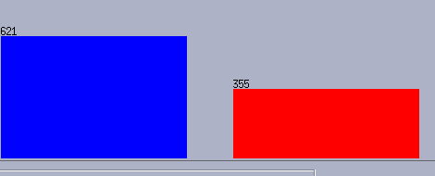
Class: File size:
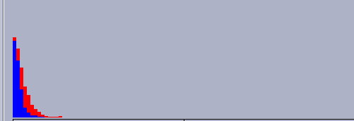

Number of out-bound link: Number of in-bound link:
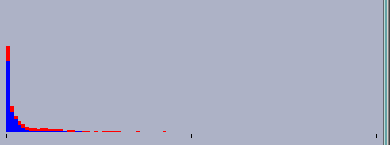
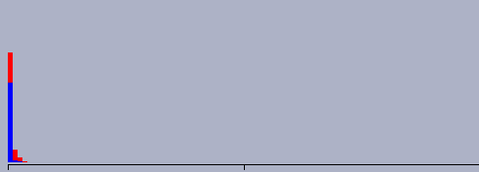
Number of Images on the Weblog: Number of changes:
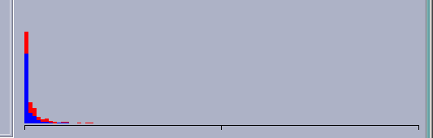
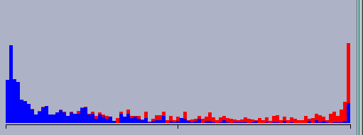
We use Weka tool for classifying our dataset. We run J48 –C 0.25 –M2 classifier in order to classify our dataset. J48 is tree classifier and 0.25 is the confidence factor and 2 is the minimum number of objects. It is shown that this classifier results in better outcome than the other classifiers. Here is the output of the Weka:

=== Run information ===

Scheme: weka.classifiers.trees.j48.J48 -C 0.25 -M 2
Relation: page_properties
Instances: 976
Attributes: 6
filesize
outboundlink_count
inboundlink_count
image_count
num_change
class
Test mode: 10-fold cross-validation

=== Classifier model (full training set) ===

J48 pruned tree
------------------

num_change <= 37
| outboundlink_count <= 104: blue (505.0/17.0)
| outboundlink_count > 104
| | num_change <= 20: blue (21.0/2.0)
| | num_change > 20: red (26.0/7.0)
num_change > 37
| outboundlink_count <= 68
| | outboundlink_count <= 15: blue (27.0/1.0)
| | outboundlink_count > 15
| | | inboundlink_count <= 23: blue (47.0/13.0)
| | | inboundlink_count > 23
| | | | num_change <= 52
| | | | | filesize <= 26204: red (5.0/1.0)
| | | | | filesize > 26204: blue (7.0)
| | | | num_change > 52: red (48.0/8.0)
| outboundlink_count > 68: red (290.0/31.0)

Number of Leaves : 9

Size of the tree : 17

Time taken to build model: 0.19 seconds

=== Stratified cross-validation ===
=== Summary ===

Correctly Classified Instances 869 89.0369 %
Incorrectly Classified Instances 107 10.9631 %
Kappa statistic 0.7653
Mean absolute error 0.1596
Root mean squared error 0.3082
Relative absolute error 34.4759 %
Root relative squared error 64.0686 %
Total Number of Instances 976

=== Detailed Accuracy By Class ===

TP Rate FP Rate Precision Recall F-Measure Class
0.902 0.13 0.924 0.902 0.913 blue
0.87 0.098 0.835 0.87 0.852 red

=== Confusion Matrix ===

a b <-- classified as
560 61 | a = blue
46 309 | b = red

As the output shows, the “Correctly Classified Instances” is 89.0369 % and “Incorrectly Classified Instances” is 10.9631 %. The confusion matrix illustrates that 560 of non-hot Weblogs out of 621 are classified correctly and 61 of non-hot Weblogs are misclassified. In addition, it shows that 309 of hot Weblog are classified correctly and 46 of hot Weblog are misclassified. Here is the decision tree that is obtained by running the J48 classifier.

Decision Tree:

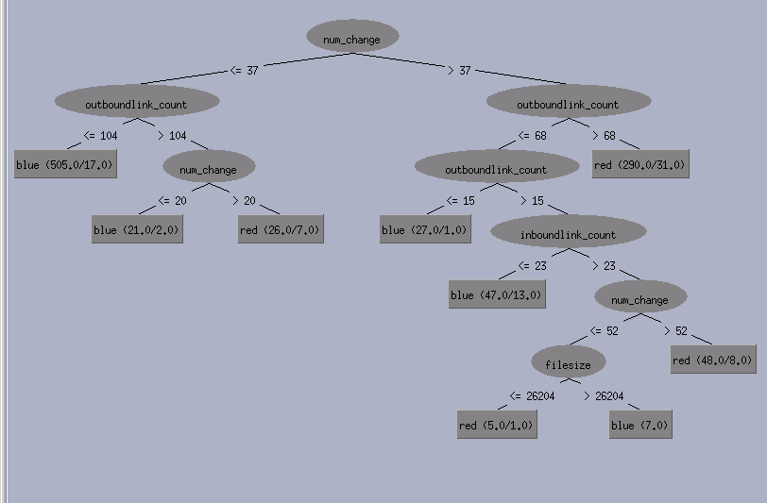

Here are some rules that are obtained from the decision tree. For example:
- If the number of changes of a Weblog is greater than 37 and its outbound links are greater than 60, then the page is Hot Weblog.

- If the number of changes of a Weblog is less or equal than 37 and its outbound links are less than or equal 104, then the page is Non-Hot Weblog.

Running other classifier on our dataset results the following confusion matrices:

NaiveBayes:
=== Confusion Matrix ===

a b <-- classified as
542 79 | a = blue
77 278 | b = red

AdaBoost with J48 classifier
=== Confusion Matrix ===

a b <-- classified as
557 64 | a = blue
60 295 | b = red

RandomForest:
=== Confusion Matrix ===

a b <-- classified as
557 64 | a = blue
64 291 | b = red

So since J48 algorithm results in better outcome, we use it as our classifier.

4.3 Prediction of popularity of discussion topics

Motivation

Having defined what discussion topics are, which are hyperlinks referring to some news stories or interesting websites, we would like to predict how popular it is in the near future. By popular we mean the total number of distinct Weblogs citing the same hyperlink. In the previous section, we observed that majority of the citations are discussion topics that appear in the first few days, it could be beneficial to predict whether a discussion will become “BIG” by applying statistic tools on the data obtained in the first few days. The followings are some possible application of this prediction:
- Content selection: In a web archiving project, while we don’t have enough storage space and processing power to store and index all versions of documents existed on the web, we might need to filter out webpage that are of low/no interest to the general public, like personal diaries; the prediction of whether a webpage will become a hot topic of discussion in the first days is essential for the filtering of content in an early stage.
- Burst detection: As topics of discussion in the Internet grow and die periodically, the automatic identification of a burst of discussion in the early stage helps attracting users to browse the website and look for interesting news.
- Better ranking: The majority of existing search engines uses PageRank as a measure of quality of web pages. However, it takes time even for a high quality page to build up its PageRank value and search engines are in fact biased towards pages of high PageRank value that built up over a pass history; thus reducing the exposure of newly created high quality web pages. As a consequence, the ability to predict popularity of a topic in the future is essential to compose a better and fairer ranking for web pages.

Experiment Setup

We focus only on the hyperlinks that had been mentioned by more than 20 distinct Weblogs over the one month monitoring period, and also received at least 4 citations when it first appear. While the total number of Weblog citations can be interpreted as a measure of popularity, the attributes we used for popularity prediction are:
- X₁ count1st8hours – as we download the same set of Weblogs every 8 hours, once a new hyperlink is detected, this is the number of Weblogs in the first batch of download that mention this particular hyperlink.
- X₂ count2nd8hours – similar to count1st8hours, this is the number of Weblogs in the second batch of download that mention it.
- X₃ count3rd8hours – similar to count2nd8hours, this is the number of Weblogs in the third batch of download that mention it.
- X₄ change2nd8hours – it is the changes in number of citations from the 1st batch to the 2nd batch of download (i.e. count2nd8hours - count1st8hours).
- X₅ change3rd8hours – it is equivalent to (count3rd8hours – count2nd8hours).
- X₆ change4th8hours – it is equivalent to (count4th8hours – count3rd8hours).
- X₇ counthotblog1st8hours – For the set of Weblogs citing this particular hyperlink in the first batch of download, this is the count of how many of them are in the hot Weblog set, which is described in previous section.
- X₈ counthotblog2nd8hours – similar to counthotblog1st8hours, it is the count on the second batch of download.
- X₉ counthotblog3rd8hours – similar to counthotblog1st8hours, it is the count on the third batch of download.

There is a total of 277 distinct hyperlinks fulfilling the criteria mentioned above, based on the 9 attributes described, we have tried linear regression (both in Weka and R), pace regression, and support vector regression to predict the total number of citations an hyperlink received (the popularity). We use the whole dataset (277 tuples) both as training and testing dataset. We use the 9 attributes together with the total number (popularity) to compose an arff file and use Weka and R to fit a linear regression model. The following are the formula we obtained and their corresponding fitting error.

- Linear Regression Model (in Weka)
Total = 0.8243 X₁ + 1.0872 X₂ + 3.8468 X₃ + 1.8611 X₆ – 1.7517 X₉ + 7.15
Absolute error: 7.793 RMS error: 12.8864
Relative absolute error: 44.2913%, Root relative squared error: 46.9638%

- Linear Model (in R)
Total = 0.86218 X₁ + 0.5487 X₂ + 4.35429 X₃ + 0.02182 X₄ – 0.51211 X₅ + 1.86443 X₆ – 0.1464 X₇ + 0.10336 X₈ – 1.76427 X₉ + 7.3244
Absolute error: 7.7556 RMS error: 12.8651
Relative absolute error: 44.1250%, Root relative squared error: 46.823%

- Support Vector Regression (in Weka)
Total = 0.9167 X₁ + 0.8684 X₂ + 3.7283 X₃ + 0.0693 X₄ - 0.2529 X₅ + 1.913 X₆ + 0.0053 X₇ – 0.4091 X₈ -1.1969 X₉ + 5.4157
Absolute error: 7.1291, RMS error: 13.3586
Relative absolute error: 40.518%, Root relative squared error: 48.6845%

- Pace Regression (in Weka)
Total = 0.8305 X₁ + 1.0817 X₂ + 3.8337 X₃ + 1.9132 X₆ - 1.5287 X₉ + 6.8867
Absolute error: 7.8131, RMS error: 12.8906
Relative absolute error: 44.405%, Root relative squared error: 46.9789%

The following graph shows the correlations between actual popularity (total number of distinct Weblogs mentioning a particular hyperlink in the one month period) and the predicted popularity using 4 different model of regression.
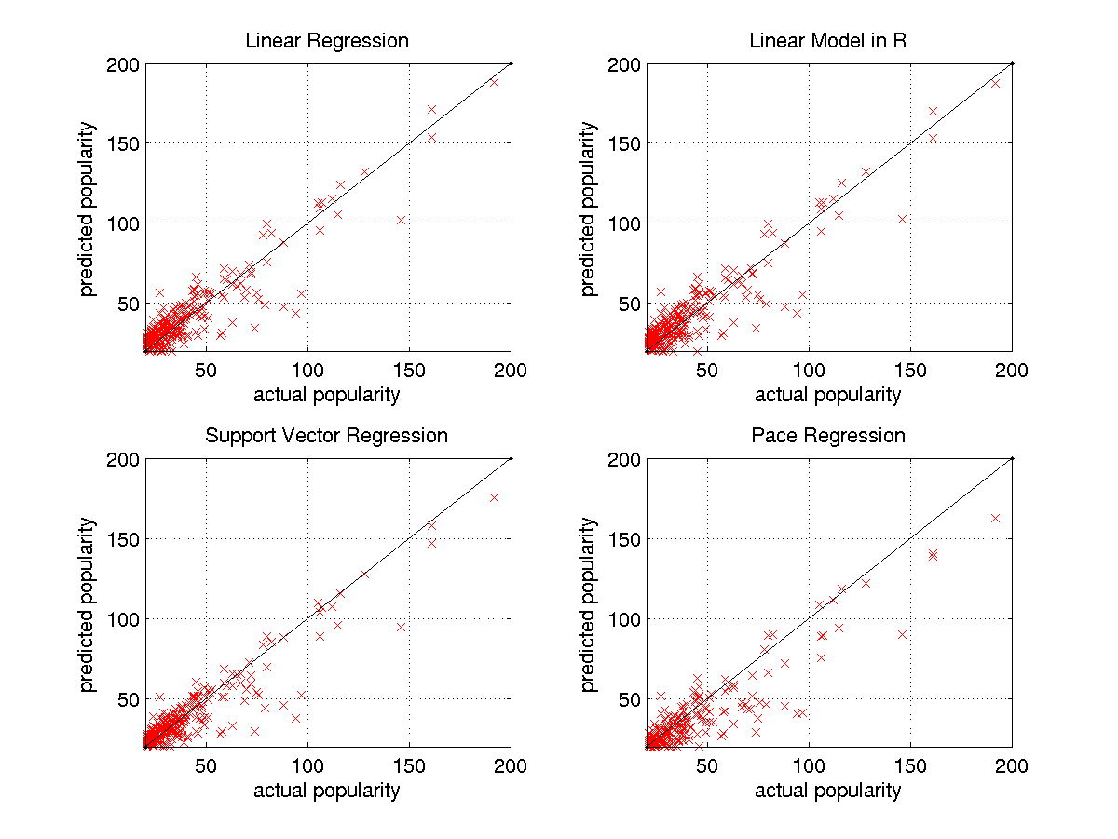

Analysis of Result

By analyzing the formula resulted from linear regression model, it is interesting to discover that the popularity of a topic is positively correlated to how many Weblogs mentioning it on the first day it appears, with the attribute X₃, which is the number of Weblogs mentioning it in the 16-24 hours after its first appearance, being a major factor. This gives us an intuition that if a topic can still arouse blogger’s interest after 1 day of its first appearance, it has the potential to become a hot topic of discussion (talk of the town).

Another observation is that whether hot Weblogs are involved in the beginning is not quite correlated to the popularity, with the exception of the attribute X₉, which is associated with a negative coefficient. This means that the number of hot Weblogs mentioning the topic after it has been appeared for a while has a negative impact on the popularity of it. A possible explanation of this counter-intuitive observation might be: if a topic is not able to get the attention of hot Weblogs, which can be interpreted as high quality commentator of information, in the very first beginning but only after some time elapse, this topic is probably unable to arouse general public’s interest.

5. Future Study – Refresh rate distribution

As mentioned above, Weblogs are generally updated more frequently than “ordinary” web pages. We might also want to figure out the population distribution in relation to the updating frequency. From a search engine point of view, maintaining an update snapshot of web pages is of central importance to deliver fresh result to the users. As the updating pattern of Weblogs are supposed to be very much different from the “ordinary” distribution, knowing this distribution of changes [3] allows us to better allocate bandwidth for crawling when building a search engine specialized for Weblogs.

6. Conclusion

In this project, we have studied the information spreading pattern among Weblogs. We show that topics of discussion generally fall into 4 different patterns. The 4 patterns we observed are: 1) A large number of Weblogs mention the topic on the first day, and it experience a rapid decay, 2) It is similar to (1) but with a slower decay, 3) The number of citations increases to a peak on the second day and decay gradually, and 4) A few Weblogs, 2 or 3, consistently discussing the same topic and span over a long period of time. Apart from this, we used C4.5 (J48 in Weka) to classify hot Weblogs, which refer to the Weblogs that initiate hot topics of discussion. The accuracy of classification reported is around 90% and it is observed that frequently updating Weblogs are usually qualified as hot Weblogs. Finally we use linear regression model to predict popularity of a topic of discussion and a fairly accurate prediction is obtained.

In conclusion, we demonstrated three areas of studies in mining Weblogs using a combination of clustering, classification and model fitting techniques covered in the class. The result obtained is useful in understanding the information flow in this new form of communication media, Weblog.

Reference

[1] Eytasn Adar, Li Zhang, Lada A. Adamic, and Rajan M. Lukose. Implicit Structure and the Dynamics of Blogspace. Technical report, HP Information Dynamics Lab, 2004. http://www.hpl.hp.com/research/idl/papers/blogs/index.html

[2] Ravi Kumar, Jasmine Novak, Prabhakar Raghavan, and Andrew Tomkins. On the bursty evolution of Blogspace. In Proceedings of the Wrold Wide Web Conference, May 2003

[3] Junghoo Cho, Hector Garcia-Molina. Estimating frequency of change. ACM Transactions on Internet Technologies, Vol 3, Number 3, August 2003, pages 256-290.

[4] D.Gruhl, R.Guha, david Liben-Nowell, A.tomkins. Information Diffusion Through Blogspace. WWW2004, May 17-22, New York, New York, USA.
Appendix A

After we parsed the raw data from Weblog, we organized and stored them in DB2, refer to section 3 in this paper. Then we used SQL command to query the database and obtained the testing data for our further analysis. We prepared 6 main input files for R and Weka and these files are located at http://sunflower.cs.ucla.edu/~kdd/ for downloading and further study purpose. Here are the list of file and their format:

Files | Format | Description
kmeanlink.arff | @ATTRIBUTE APP1 REAL  @ATTRIBUTE APP2 REAL  @ATTRIBUTE APP3 REAL  @ATTRIBUTE APP4 REAL  ……  @DATA  0.428571,0.476190,0.000000,…. | This file contains 36 attributes represent number of url cited within 36 days testing period. Furthermore, there are 605 testing urls.  (Refer to section 4.1 – information spreading pattern using k-mean clustering algorithm)
hotBlogs_classifier.arff | @ATTRIBUTE filesize INTEGER  @ATTRIBUTE outboundlink_count INTEGER  @ATTRIBUTE inboundlink_count INTEGER  @ATTRIBUTE image_count INTEGER  @ATTRIBUTE num_change INTEGER  @ATTRIBUTE class {blue,red}  @DATA  277,0,0,0,1,blue  293,0,0,0,1,blue  391,0,0,0,1,blue | This file contains the dataset with 621 non-hot Weblog and 355 hot Weblog. We used this file for correctly classifying our dataset.  (Refer to section 4.2 – Hot Weblog Discovery using classification)
hotBlogs_original.arff | @ATTRIBUTE filesize INTEGER  @ATTRIBUTE outboundlink_count INTEGER  @ATTRIBUTE inboundlink_count INTEGER  @ATTRIBUTE image_count INTEGER  @ATTRIBUTE num_change INTEGER  @ATTRIBUTE class {blue,red}  @DATA  2,0,0,0,1,blue  15,0,0,0,1,blue  34,0,0,0,1,blue | This file contains the dataset with 30,716 non-hot Weblog and 355 hot Weblog. Using this dataset, any classifier algorithm results in misclassifying majority of hot Weblog.  (Refer to section 4.2 – Hot Weblog Discovery using classification)
predictlife.arff | @ATTRIBUTE count1stday INTEGER  @ATTRIBUTE count2ndday INTEGER  @ATTRIBUTE count3rdday INTEGER  @ATTRIBUTE count1st8hours INTEGER  @ATTRIBUTE count2nd8hours INTEGER  @ATTRIBUTE count3rd8hours INTEGER  @ATTRIBUTE change2nd8hours INTEGER  @ATTRIBUTE change3rd8hours INTEGER  @ATTRIBUTE change4th8hours INTEGER  @ATTRIBUTE counthotblog1st8hours INTEGER  @ATTRIBUTE counthotblog2nd8hours INTEGER  @ATTRIBUTE counthotblog3rd8hours INTEGER  @ATTRIBUTE totalblogmetnion INTEGER  @DATA  19,2,1,8,7,4,-1,-3,-2,3,4,1,23  13,6,3,7,2,4,-5,2,-2,3,0,1,32 | This file contains 13 attributes represent the count in first 3 days, the count in first three hours, the change in 2-4 8-hour, the count of hot Weblog in the first 8 hour, and the total Weblog that mentioned about the url.
predictlife.R | This file contains R source code to generate the four predication graphs in section 4.3 of prediction of popularity of discussion topics
predictlife4.data | This file contains the dataset for predictlife.R

